Class Work 1 – Android Studio: App Development  
Andrei Koshelev  
100894383  
  
3101-02  
INFT  
  
Durham College  
Mohammad Shamas  
  
  
Friday, September 27th, 2024

**Table of Contents:**Cover Page …………………………………………….............................................. p. 1

Table of Contents ........................................................................................................ p. 2

Code for Activity_main.xml ………………………........................................... pp. 3 – 6

Screenshot of the app output in the Android Studio emulator ............................ pp. 6 – 7

Screenshots of the app output in the external emulator (BlueStacks): ................ pp. 7 – 8

Reflection ..................................................................................................................... p. 9

**Code for Activity_main.xml:**

<?xml version="1.0" encoding="utf-8"?>  
<androidx.constraintlayout.widget.ConstraintLayout xmlns:android="http://schemas.android.com/apk/res/android"  
 xmlns:app="http://schemas.android.com/apk/res-auto"  
 xmlns:tools="http://schemas.android.com/tools"  
 android:id="@+id/main"  
 android:layout_width="match_parent"  
 android:layout_height="match_parent"  
 tools:context=".MainActivity"  
 android:background="@drawable/classwork1backgroundsky">  
  
 <TextView  
 android:id="@+id/fullName"  
 android:layout_width="wrap_content"  
 android:layout_height="wrap_content"  
 android:fontFamily="casual"  
 android:text="Andrei Koshelev"  
 android:textAlignment="center"  
 android:textColor="#00FFF5"  
 android:textColorLink="#FF0000"  
 android:textSize="20sp"  
 android:textStyle="normal"  
 app:layout_constraintBottom_toBottomOf="parent"  
 app:layout_constraintEnd_toEndOf="parent"  
 app:layout_constraintHorizontal_bias="0.535"  
 app:layout_constraintStart_toStartOf="parent"  
 app:layout_constraintTop_toTopOf="parent"  
 app:layout_constraintVertical_bias="0.245" />  
  
 <TextView  
 android:id="@+id/favoriteQuote"  
 android:layout_width="290dp"  
 android:layout_height="75dp"  
 android:fontFamily="@font/akaya_kanadaka"  
 android:text="“I'd rather be hated for who I am, than loved for who I am not.” ― Kurt Cobain"  
 android:textAlignment="center"  
 android:textColor="#A2FF69"  
 android:textSize="20sp"  
 app:layout_constraintBottom_toBottomOf="parent"  
 app:layout_constraintEnd_toEndOf="parent"  
 app:layout_constraintHorizontal_bias="0.636"  
 app:layout_constraintStart_toStartOf="parent"  
 app:layout_constraintTop_toTopOf="parent"  
 app:layout_constraintVertical_bias="0.567" />  
  
 <TextView  
 android:id="@+id/classAndSection"  
 android:layout_width="wrap_content"  
 android:layout_height="wrap_content"  
 android:fontFamily="sans-serif-black"  
 android:text="INFT 3101-02"  
 android:textAlignment="center"  
 android:textColor="#F67E59"  
 android:textSize="20sp"  
 android:textStyle="italic"  
 app:layout_constraintBottom_toBottomOf="parent"  
 app:layout_constraintEnd_toEndOf="parent"  
 app:layout_constraintHorizontal_bias="0.534"  
 app:layout_constraintStart_toStartOf="parent"  
 app:layout_constraintTop_toTopOf="parent"  
 app:layout_constraintVertical_bias="0.43" />  
  
 <TextView  
 android:id="@+id/bannerID"  
 android:layout_width="wrap_content"  
 android:layout_height="wrap_content"  
 android:fontFamily="cursive"  
 android:text="100894383"  
 android:textAlignment="center"  
 android:textAppearance="@style/TextAppearance.AppCompat.Medium"  
 android:textColor="#9F55DB"  
 android:textSize="20sp"  
 android:textStyle="bold"  
 app:layout_constraintBottom_toBottomOf="parent"  
 app:layout_constraintEnd_toEndOf="parent"  
 app:layout_constraintHorizontal_bias="0.532"  
 app:layout_constraintStart_toStartOf="parent"  
 app:layout_constraintTop_toTopOf="parent"  
 app:layout_constraintVertical_bias="0.336" />  
  
</androidx.constraintlayout.widget.ConstraintLayout>

**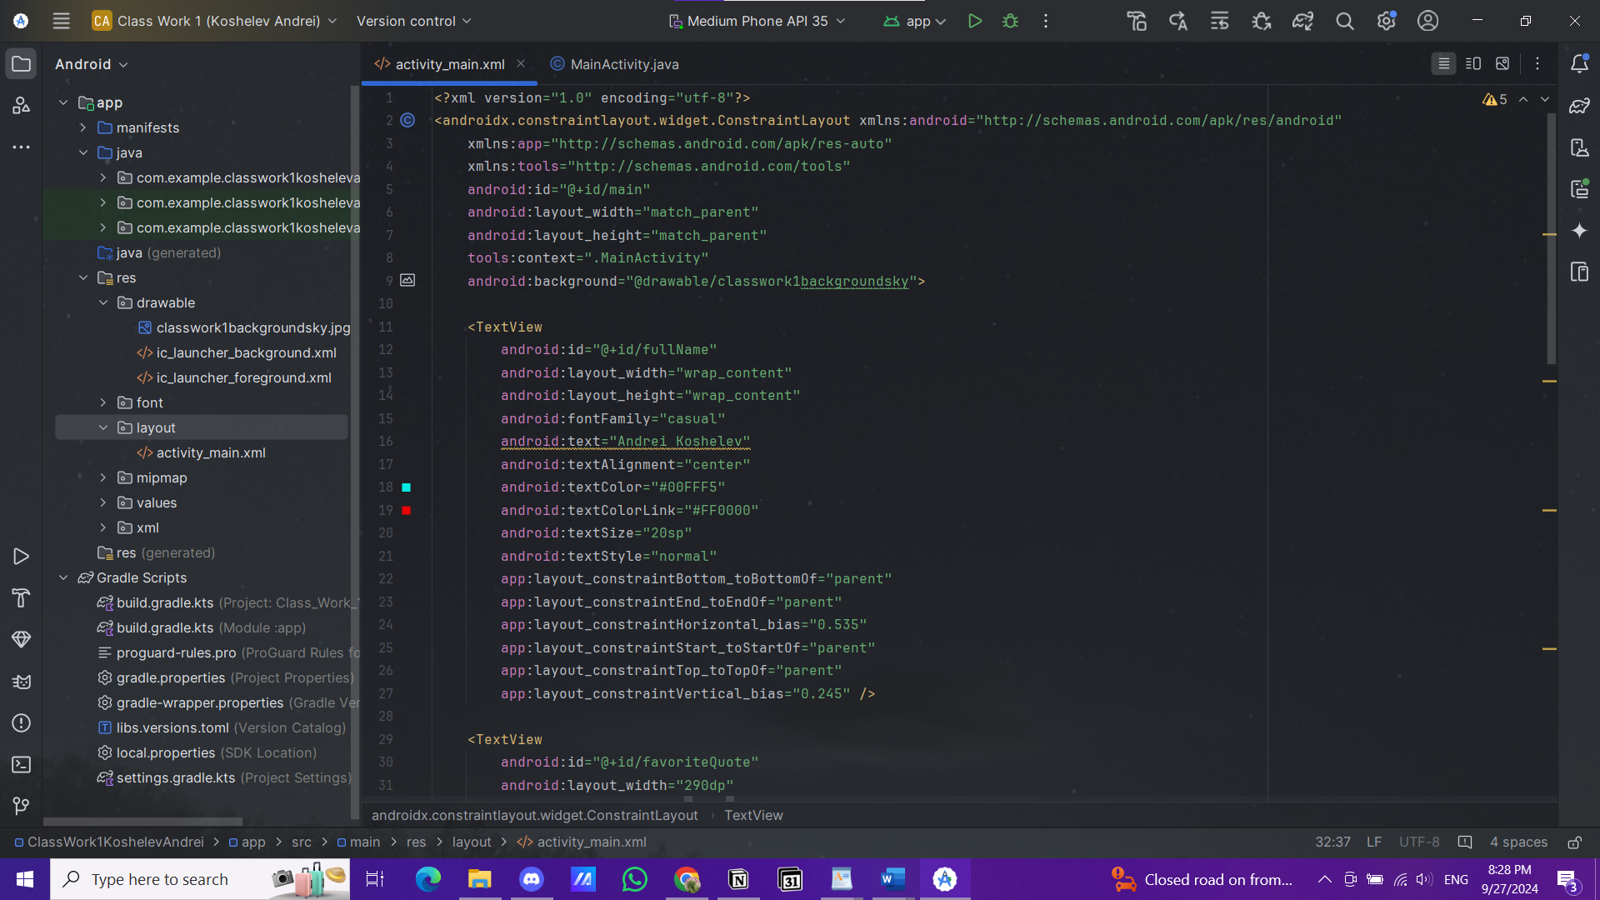  
  
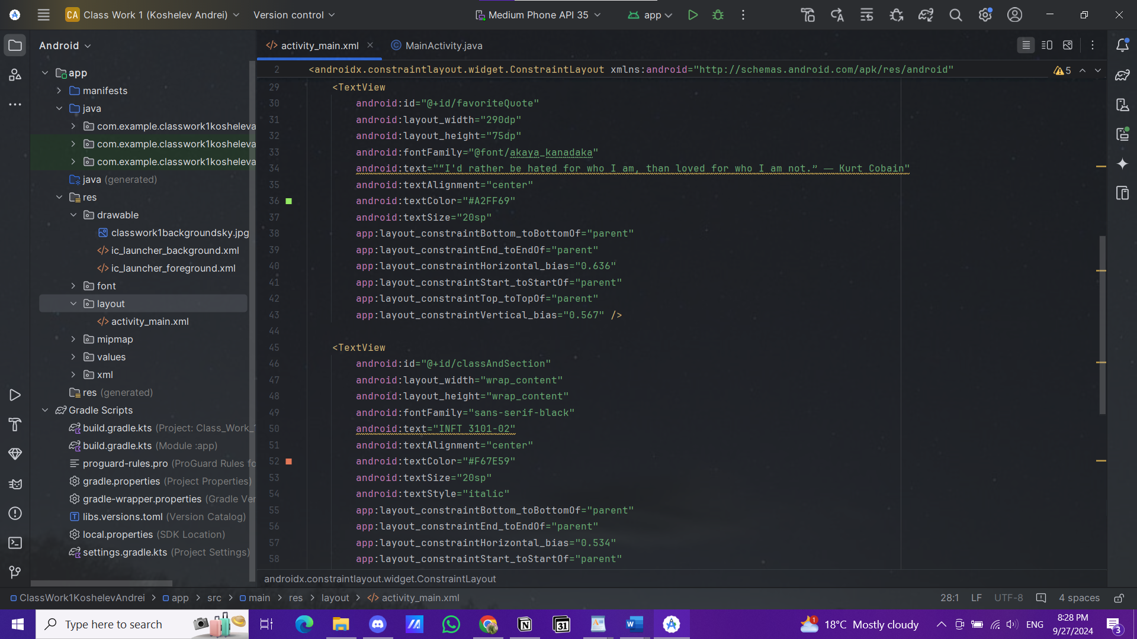  
  
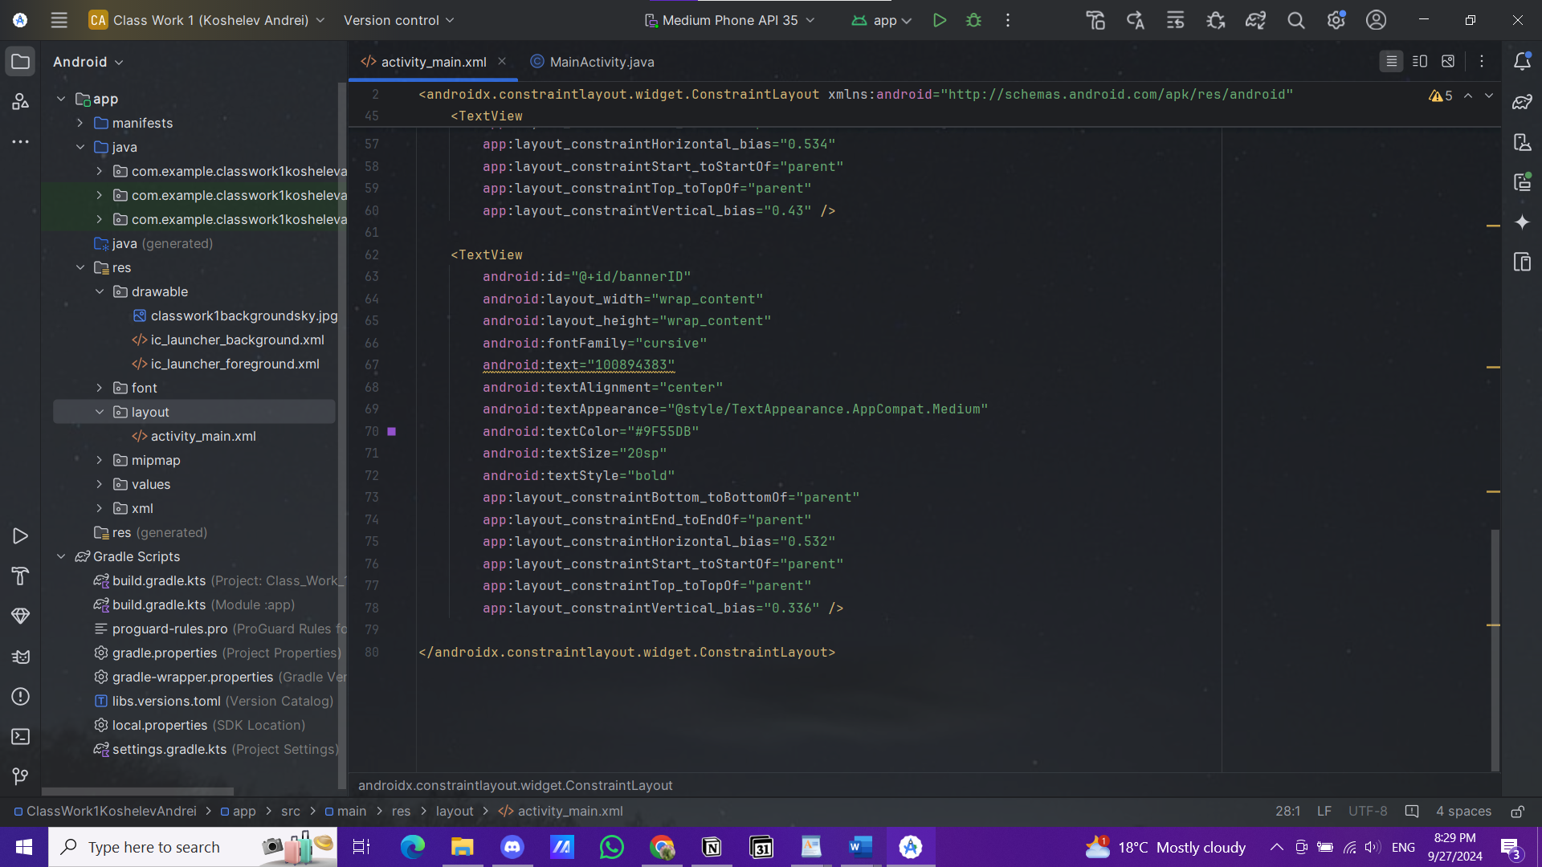  
  
  
Screenshot of the app output in the Android Studio emulator:  
  
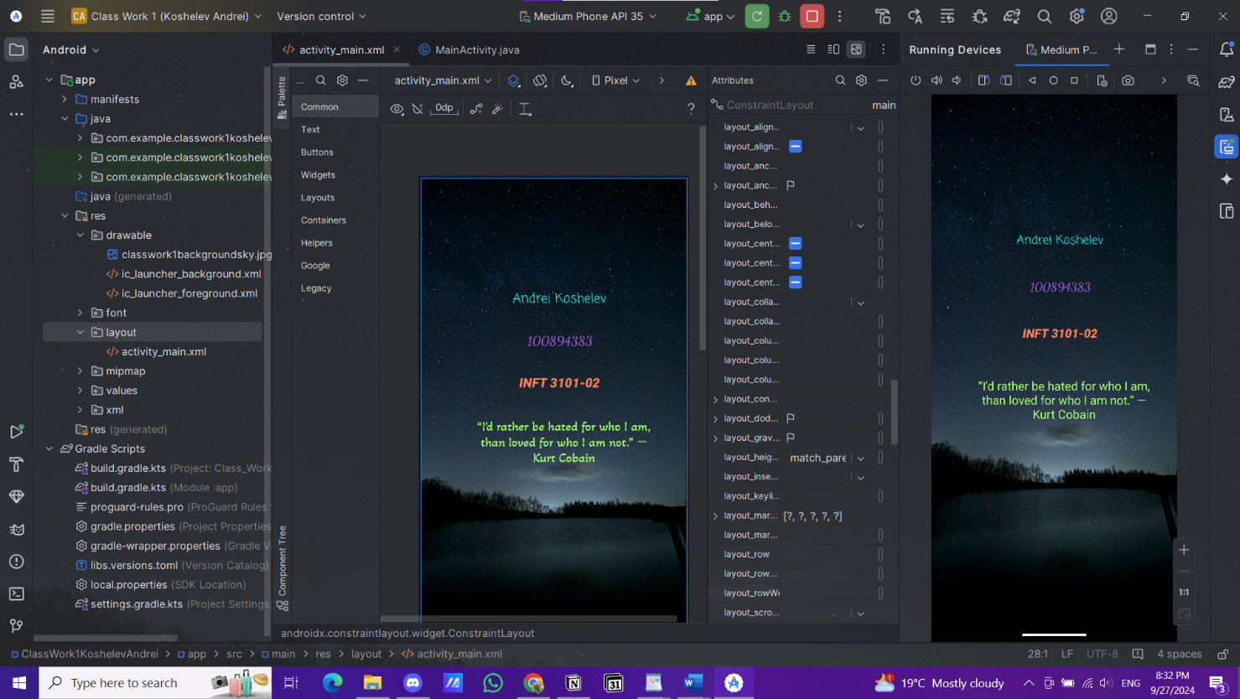  
  
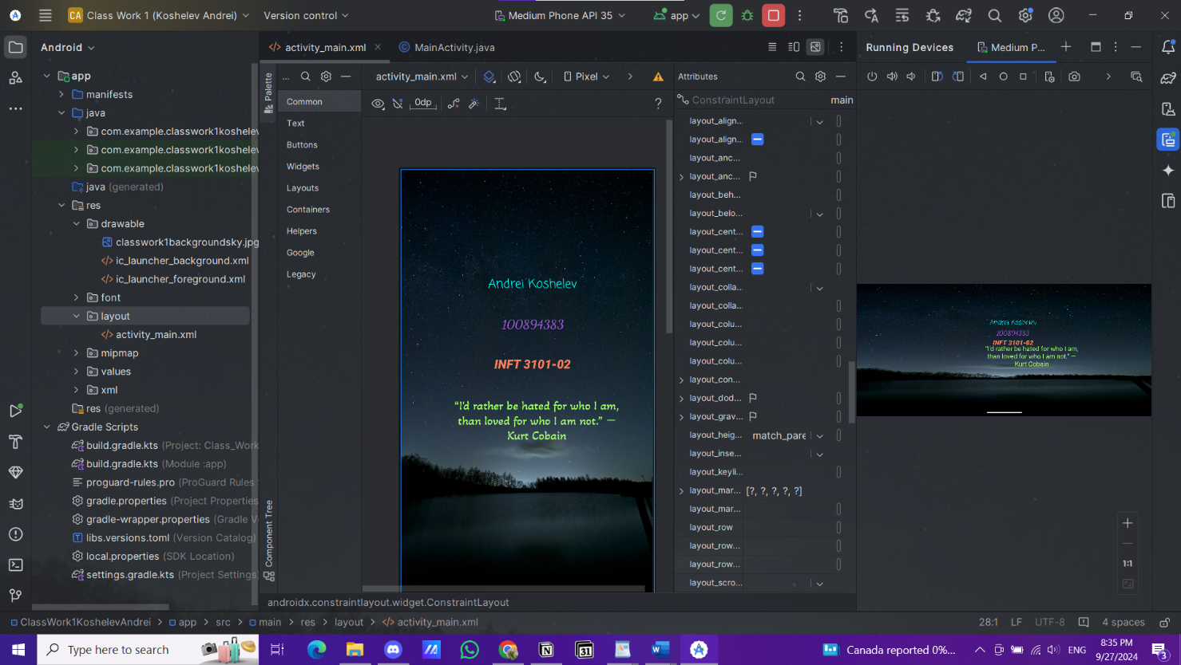  
  
  
Screenshots of the app output in the external emulator (BlueStacks):  
  
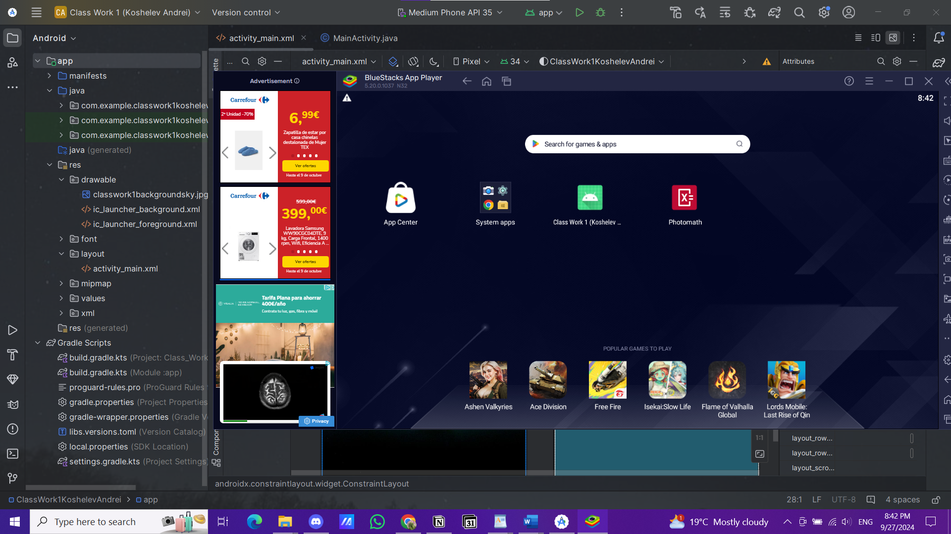  
  
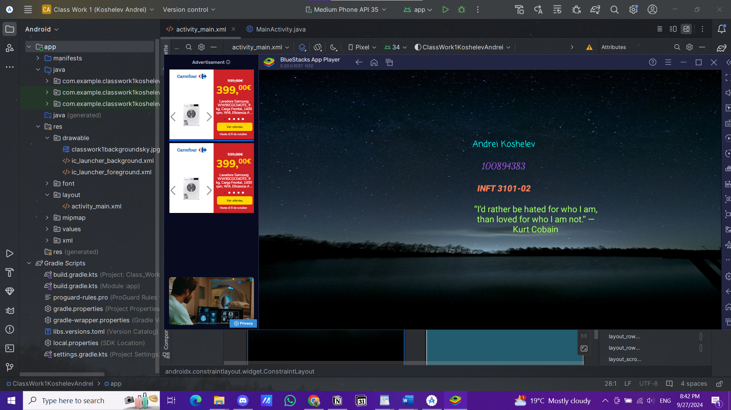  
  
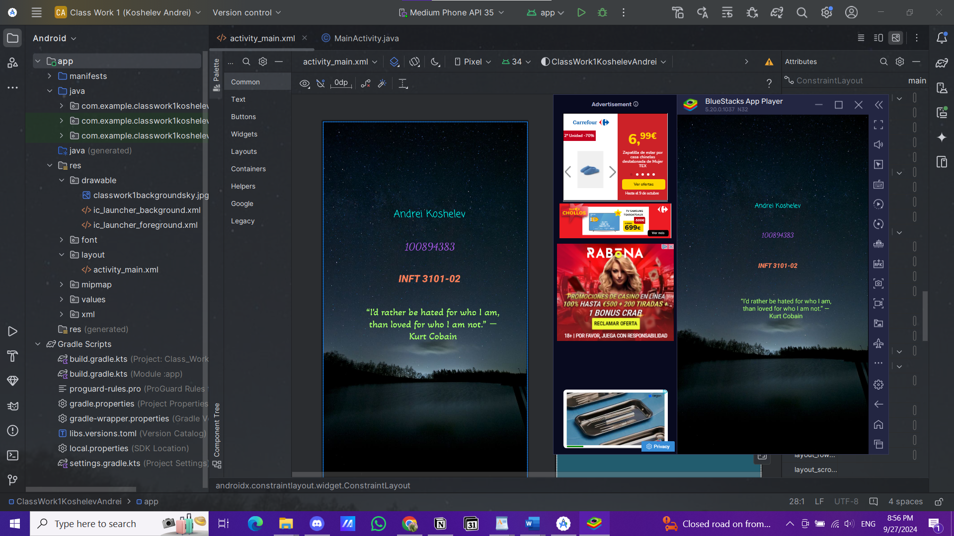  
  
  
  
  
Reflection:**

I ran into a few obstacles while completing this assignment. I a bit mixed up the background configuration of the app with the Android Studio environment which was one of the initial challenges. It took some time to figure out what I was doing wrong, but it was not too hard to solve. Furthermore, the Android Studio App Emulator took a while to load, which increased the workload for the computer's fans. Another small problem was that the screenshots that I took while the emulator of Android Studio App was working, for some reason, restricted me from pasting the screenshot directly into the word document, so I had to manually insert saved snapshots into the word document after saving it on my laptop. Overall, I liked using Android Studio App so far and I think it is straightforward so far and I am of course excited to code more mobile apps using this program.